CONSTRUCTION TRAFFIC MANAGEMENT PLAN

Address

DA-###/####

Date

Table of Contents
1 Project Summary 3
2 Project Schedule 3
3 Construction Hours 3
4 Size and type of trucks expected 4
5 Truck access 4
6 Construction zone requirements 6
7 Parking of light vehicles 6
8 Storage and skip bins 6
9 Neighbours 6
10 Pedestrians 7
11 Contact Details 7
12 Miscellaneous 7
13 Traffic Guidance Schemes 7

Project Summary

Site address
Development Application (DA) Number
Condition number
Author of the CTMP
Date
Description of the development

Contact Details

Position | Name | Phone number | Email
On-site contact
Project manager

Project Schedule

The proposed works are on:

Task | Duration
Site establishment
Demolition and excavation
Construction

Construction Hours

Demolition and building work will only be undertaken in the following hours:

Days | Hours of work
Mondays to Fridays | 7am to 5pm
Saturdays | 8am to 3pm
Sundays and public holidays | No work to be carried out

Excavation works involving the use of heavy earth movement equipment including rock breakers and the like will only be undertaken between the hours of 7am and 5pm on Mondays to Fridays with no such work to be carried out on Saturday, Sunday, or a public holiday.

Noise from construction activities shall comply with the Protection of the Environmental Operations (Noise Control) Regulation 2017.

Size and type of trucks expected

Task | Size and type of vehicles
Site establishment
Demolition and excavation
Construction

Trucks servicing the site will only enter and exit the street during the approved construction hours.

Trucks servicing the site are less than 10 metres in length. A separate application will be submitted to Council for vehicles longer than 10 metres to be used on specific dates.

Truck access
- Trucks servicing the site shall enter/exit X Street during the approved construction hours only. (Identify the streets that will be used for direct access to the site. This may be the site address and/or a laneway at the rear).
- Truck access to and from the site shall be as per the Construction Traffic Management Plan.
- Truck layover
  - Trucks not able to enter the site or a Council approved Construction Zone immediately shall wait remote from the site in legal parking spaces and enter the street only when the area is clear for access.
  - Trucks waiting in a layover location remote from the site shall not do so until after 6.30 am if parked outside residential premises.
  - Trucks waiting at or near the site or in a layover location shall have their engines turned off for the duration of the stay.
- Vehicles reversing into or out of the site shall be controlled by accredited traffic controllers.
A map of routes to be taken by truck drivers is included.

Map for routes to be taken by truck drivers | 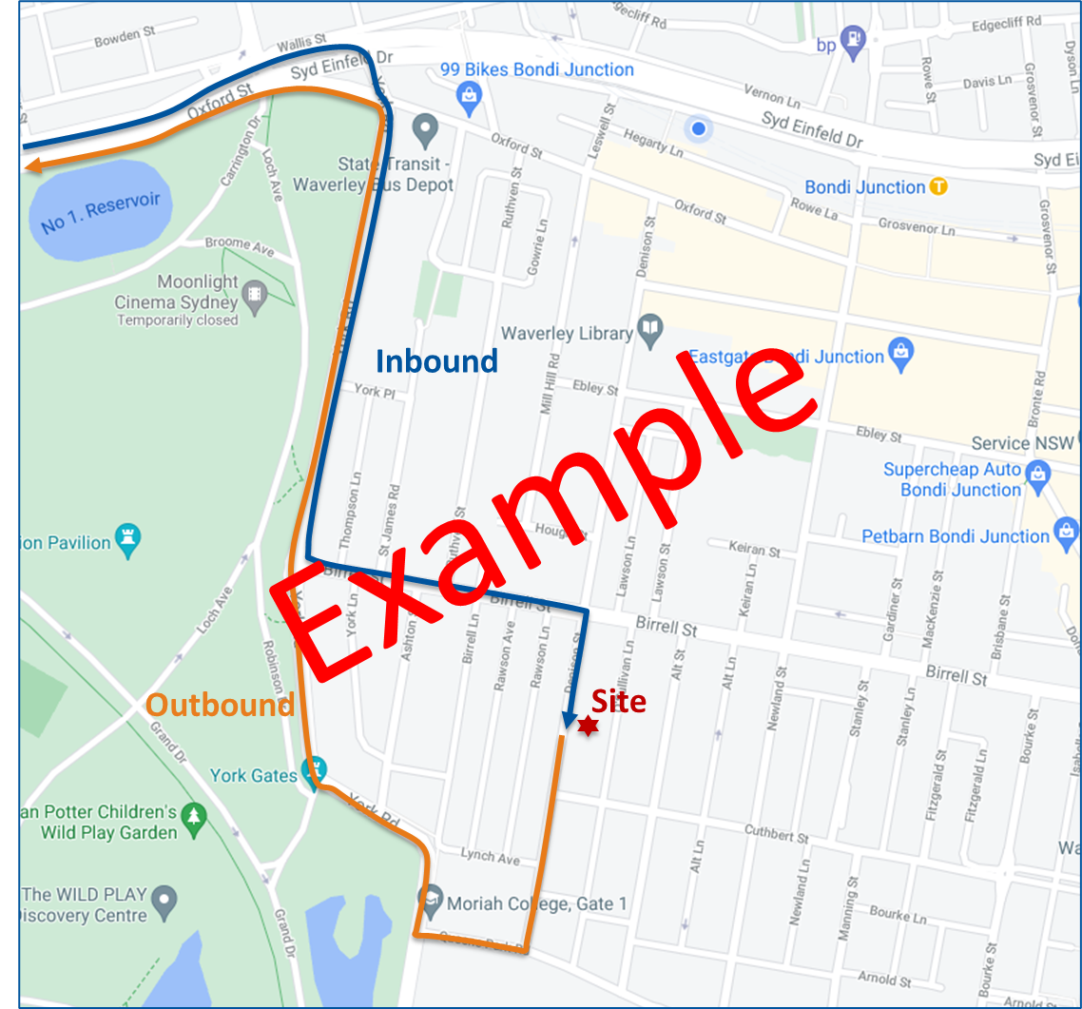

Construction zone requirements

A construction zone is not proposed at this stage.

or

A __ meter long construction zone is anticipated in front of the site. A separate application will be submitted for the construction zone. | 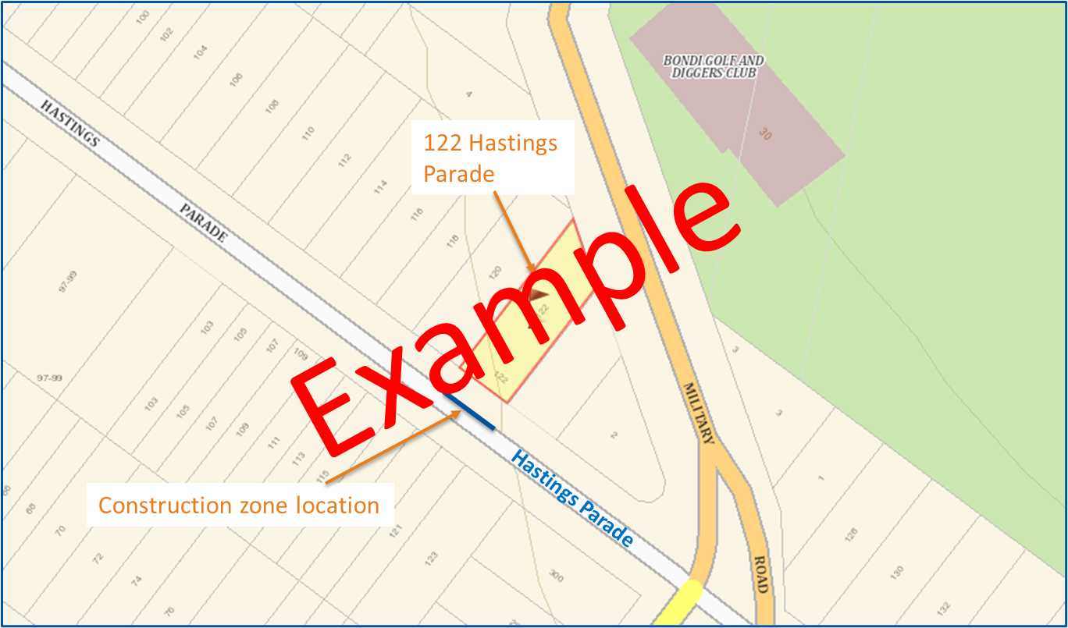

Parking of light vehicles

Light vehicles will be accommodated on-street. If a construction zone is approved and installed, some light vehicles will be accommodated within the planned construction zone when it is not required for trucks.

Storage and skip bins

No materials will be placed, dumped or left on any Council road or footpath area at any time. Skip bins are / are not anticipated to be required.

Applications for placement of bins will be subject to a separate application

Neighbours

The following addresses will be notified by letterbox drop prior to start of construction activities of the programmed timing of works:

Adjacent to the site
Opposite the site
At the rear of the site

Pedestrians

Pedestrians will not be affected. There will be no blocking of footpaths. Pedestrians will be assisted by traffic controllers when potential conflicts could occur.

Miscellaneous
- Removed or damaged parking signs shall be replaced immediately.
- Damaged trees shall be repaired / replaced to the satisfaction of Council.
- Traffic and pedestrian control shall be in accordance with the TfNSW Traffic Control at Work Sites Technical Manual and Australian Standard AS1742.3 – Manual of uniform traffic control devices - Part 3 Traffic control for works on roads.
- Reserving of on-street parking shall not occur without prior Council approval. All on street parking spaces outside the site are to remain available for the use by the general public during the approved work hours unless Council signage is installed to the contrary.
- Barricades, delineators (including bollards, witches hats, barrier boards etc.) shall not be placed in the kerbside parking lane outside or adjacent to the site to reserve on street parking spaces without the prior approval of Council.
- A separate application to and approval from Council will be submitted for occupation of any road related area (traffic and parking lanes, verge, footpath etc.)

Traffic Guidance Schemes

You can adopt the schemes below in most cases.

