MINUTES OF THE MEETING OF

DOVER HEIGHTS PRECINCT

Monday 22nd August

at Tre Pani Bakery/Café
218 Military Road Dover Heights – 7:30pm

Attendance: Mayor Cr Betts, Cr Guttman-Jones, Cr Goltsman and as per attendance sheet

John Lewis: Meeting Chairman
Michael Lewis: Secretary
Meeting commenced at 7:39pm.

JL: Welcomed the Ward councillors and attendees.

Arising from Minutes 16th May 2011

DF: Asked about increasing Base Rate
SB: Councils’ meeting raised this as issue to pass on to the Minister – Don Paige.

Bye Election
Leon Goltsman received 76% of primary votes – preferences were not needed.
Discussion about whether the election was needed. Green candidate took it seriously.
Labor did not bother attending the Pre Poll.
Was supposed to be an issue concerning the Mayor – vindicated her stands.
JL: All Ward councillors service the Ward enthusiastically.

Cliff Walk Deterioration. Mayor asked officers to check

Accepting Minutes
Dov Frazer, Vicki Saffer ,Accepted

Parks & Reserves
DF: Portland St footpath under repair.
Compromise with Rodney Reserve bins – Wheely Bins chained to pole etc.

Resolutions:
Concerning the sea fence of Rodney Reserve

Motion: Wire Fence in Rodney Reserve between Radio Telescope to just south of Dover Road be replaced and the precinct recommends it be replaced with treated pine, joined with stainless steel, square-head screws and the Verge Plants which are destroying it, be removed.
Moved Dov Frazer and Mark Coughlan – carried unanimously.

Ron Nothman: In past fence was wood, which eventually failed and the metal fence replaced it.

The metal has rotted. You can now get treated pine (wood) joined with special corrosion resistant, difficult to unscrew, screws which last much better than metal. (40 years). Metal fences have lasted approx 10 years.

Motion: Broken Storm Water Drains, under Eastern Ave and Rodney Reserves – causing bogs, be repaired along with, at Rodney Reserve, the collapsed embankments..
Moved Dov Frazer, Jackie Lewis, Unanimously

Rodney Reserve where fence recommendation applies, the bank has been eroded

Weonga Road - Council replaced drains at end and in process created a “mess” at the site. Council made various attempts – now “too hard’.

DF suggests painting the asphalt black or repaving that small area
RM: suggested using HCL/High Pressure hose would solve issue

Motion: Council should clean up mess at end of Weonga Road, in front of the storm drain that they created, by removing the concrete from the asphalt.
Moved Dov Frazer, Ron Nothman Carried

RM: Graffiti on Dudley Page: No cameras
RN “caught” people and reported them to Police “regular” tagging. Can now be removed readily by Sydney Water since they repainted it.

Traffic and Parking
Boat parking – Portland St now solved. Now there are more boats on Military Road between Wentworth and Golf Club. Portland St solution should be applied here.
ML: Problem will just move – e.g. to Young St in Vaucluse next to South Head Cemetery. Needs change to legislation with respect to parking of trailers.
Cr Jones: At City to Surf, all boats were moved to other streets.

Motion:
A parking restriction be placed in Military Road between Wallis Parade and O’Donnell St, – on both sides similar to that now in place in Portland St.
Moved John Lewis, Dov Frazer, Carried

ML: RTA Clearways at City to Surf, in Military Road – unnecessary and with stupid times. 1am to 4pm – no relation to reality – similar to New Years Eve. Being applied with no understanding of local traffic.

Traffic:
Congestion in Blake St between Portland and Military
Alan Brenner - Myuna Rd. Congestion in Blake St between Portland and Military is becoming dangerous. A home in the section parks an overweight truck – with apparent impunity. The paths could be narrowed to allow safer car movements. Cars parking cause havoc. “Fobbed off” by Council. Really, one side of section needs permanent “no parking”.

Motion: No Stopping be applied to the north side of the section of Blake St, between Portland St and Military Road.
Moved Alan Brenner, Dov Frazer - Carried

AB: Myuna Rd receives tourism parking on ends into Military Rd – makes it difficult to turn into and out of Myuna Road. Pace out 6 metres from end and check with residents.

SB: RTA is allowing a trial of “half on curb” parking in Gilbert St.

General Business:

Mr Wayne : Wants stairway at end of Raleigh between Hardy and Raleigh.
Little traffic changes in Waverley with respect to increase of cars. Traffic light in OSHR in wrong places.
SB: OSHR is an RTA road – tend to ignore Council.

Gerorge Fisher - Dover Road: Local play centres need Shade Covers.
SB: Impossible to find money.
DF: No one nearby would like their views endangered – Many issues.

AB: Early Morning Garbage Collection noise – why so early and so noisy? Discussion with many points of view.

JL: Has Council calculated cost of carbon tax?
SB: No one knows until Tax applies

JL: Article in Wentworth Courier. Residents can prune park trees – Woollahra Council decision.
Why can’t Waverley?
Hilma M Trees which stop light can.

SB: Ward councillors will look at Woollahra Council decision and check its relevance for Waverley.

Energy Australia is making many changes throughout Waverley – process full of delays – when eventually done, the streets will be replaced.

VS: Plants in Blair St are a “mess”.

Thanks to Tre Pani Management

Meeting finished at 9:15 pm

Next Meeting:
Monday 21st November

Appendix – Collapsed Embankment In Rodney Reserve Below
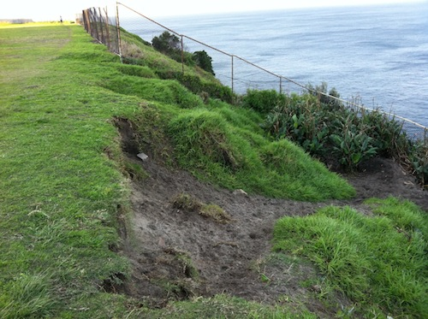
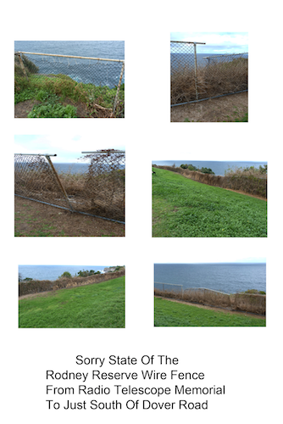
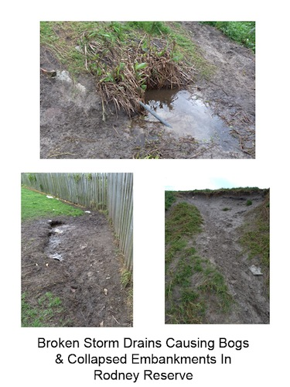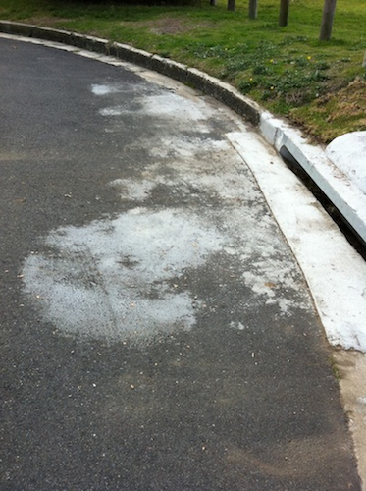

Concrete Slurry Mess On Asphalt in Front of Storm Drain – Weonga Road
Caused by Council When Storm Drain was Replaced

